Where Shoppers Drop Off
E-commerce funnel, product and retention analytics in SQL
By Uloh C. Armstrong
Analyst’s technical report. SQL project (SQLite dialect) for a Product Manager’s questions on engagement, conversion, abandonment, product performance and retention.
Data: synthetic e-commerce event database (ecommerce_clean.sqlite) · 26 weeks, 7 Jul 2025 - 4 Jan 2026 · 30,000 users · 89,557 sessions · 590,648 events · 6,896 orders

Item | Status
sql/ecommerce_product_analytics.sql (one file, 7 sections) | 2,072 lines. Executed end to end with the sqlite3 shell 3.45.1 (exit code 0, 33.4 s) and with SQLite 3.53 through the Python runner (70 blocks, 35.5 s). The two runs produced identical contents in all 30 tables and views.
Validation checks (Section 7) | 27 of 27 PASS, 0 FAIL. A seeded-error test on a copy made 6 checks fail as expected.
Raw data | Attached read-only; MD5 451c337ac01d6286b2a1575b246ed178 before and after every run.
Result files | 41 CSV outputs (34 analytical queries Q01-Q28, 5 data-quality and 2 validation outputs) and 7 cleaned-table exports.

1. Project overview
Item | Detail
Project title | Where Shoppers Drop Off: E-commerce Funnel, Product and Retention Analytics in SQL
Business scenario | A Product Data Analyst at an e-commerce technology company. The Product Manager wants to understand how users interact with the platform, where they abandon their shopping journeys, and which products or user behaviours are associated with successful purchases. The task is to turn the event records into product performance metrics.
Business problem | The company sees traffic and orders, but not the journey between them. Without a measured funnel it cannot tell which stage to fix, which products waste attention, or which users and channels bring lasting engagement.
Purpose of the analysis | Measure engagement, build the view-to-purchase funnel, locate abandonment, assess products and categories, measure returning-user behaviour and cohort retention, and turn the results into prioritised opportunities.
Scope | All 590,648 events, 89,557 sessions, 30,000 users, 6,896 orders and 250 products in the 26-week window. Descriptive and diagnostic. Out of scope: causal attribution (no experiments in the data), forecasting, profitability and channel return on spend (no cost data).
Tool used | SQL, SQLite dialect (version 3.35 or later required; tested on 3.45.1 and 3.53). The whole analysis is one SQL file. Python is used only to run that SQL and export results (standard library) and to draw charts from the exported results (pandas, matplotlib). No analysis is done in Python.

2. Business objectives and analytical questions

2.1 Objectives (as supplied)
- Measure user engagement with the digital platform.
- Analyse the conversion funnel from product views to purchases.
- Identify stages at which users abandon their shopping journeys.
- Examine product and category performance.
- Analyse returning user behaviour and retention patterns.
- Identify opportunities to improve conversion and user engagement.

2.2 Analytical questions (as supplied) and how they were translated
Question | Analytical requirement | Output
How many unique users interacted with the platform? | Distinct users with a session; registered vs guest | Q01
How many product views were recorded? | Count product_view events, and separately those traceable to a product | Q01
How frequently do users return to the platform? | Sessions per user (distribution), gap between sessions, weekly returning users | Q03, Q03b, Q04
What is the average number of product interactions per session? | Define product interaction; mean and median per session | Q02
Which products receive the most views? | Rank products by views; view concentration | Q06, Q06b
How many users viewed products, added items to their carts and completed purchases? | Closed user funnel with purchases from orders (system of record) | Q07, Q07b
What percentage of viewers add products to their carts? | Step conversion view → cart | Q07, Q08
What percentage of cart users complete a purchase? | Cart → checkout → order | Q07, Q08
At which stage does the largest drop-off occur? | Rank step drop-offs; by platform, device and source; behaviour after add-to-cart | Q07, Q09–Q12b
Which products have the most views? | As above, with conversion alongside | Q06
Which products have the highest view-to-purchase conversion? | Viewer → buyer rate per product, ranked by Wilson lower bound (≥ 500 viewers) | Q14
Do popular products necessarily generate the most purchases? | Spearman correlation; overlap of top lists; popularity / conversion quadrants | Q13, Q13b, Q26
Which categories have the highest purchase activity? | Orders, buyers, units, conversion and shares by category | Q16
Which products experience relatively high cart abandonment? | 7-day cart outcome, censoring-aware; product vs category and overall | Q17, Q17b
How many users return after their first observed interaction? | Return on a later day; within 7 / 14 / 28 days among eligible users | Q19
How does activity change across weekly user cohorts? | Cohort × week-offset retention matrix (recursive CTE) | Q20, Q22
What proportion of users return after one, two or four weeks? | Pooled week-1 / 2 / 4 retention over observed cohorts; three populations | Q21
Which user groups show stronger repeat engagement? | Return and repeat-buying by channel, device, city, registration, loyalty, first-session outcome | Q23, Q24
Objective 6 draws on all of the above. Q25 consolidates the sized opportunities, and Q18 adds promotion periods. The full objective-to-query mapping, with techniques, is in docs/project_brief.md.

3. Dataset overview
Source file: ecommerce_clean.sqlite (66 MB), supplied with the brief and stored unchanged at data/raw/. The data is synthetic. It simulates a Nigerian marketplace (the app user agent is “OjaLoop”, the brands are fictional, the cities are Nigerian). It does not describe a real business.
Table | Rows | Grain | Key fields
events | 590,648 | one interaction | event_type, product_id, session_id, user_id, order_id, event_timestamp
sessions | 89,557 | one visit | device_type, platform, traffic_source, session_start/end
users | 30,000 | one user | signup_date (NULL = guest), acquisition_channel, city, is_loyalty_member
orders | 6,896 | one order | order_status, items_subtotal, session_id
order_items | 10,808 | one order line | product_id, quantity, unit prices, line_total
products | 250 | one product | category_id, list_price, is_active
categories | 10 | one category | category_name, department
promotions / promotion_products | 6 / 311 | promotion; product in promotion | start/end dates, scope, discount_pct
calendar | 182 | one day | week_index (1–26), is_weekend, promotion_name

3.1 Structure
The data is a star-like transactional model. events is the fact table at the finest grain and points to sessions, users, products and (for purchases) orders. orders points to users and to the session in which the order was placed, and order_items holds its product lines. The calendar provides the Monday-start weeks used for every weekly metric and cohort. Section 2 of the SQL recreates every relationship as a declared FOREIGN KEY, and PRAGMA foreign_key_check returns no violations.

3.2 Event types
event_type | Events | % missing product_id | % missing order_id
product_view | 311,955 | 0.45% | 100.00%
page_view | 157,849 | 100.00% | 100.00%
search | 65,586 | 100.00% | 100.00%
add_to_cart | 28,941 | 0.44% | 100.00%
purchase | 10,497 | 0.00% | 0.00%
begin_checkout | 9,816 | 100.00% | 100.00%
remove_from_cart | 6,004 | 0.00% | 100.00%

3.3 Dataset limitations
- The data is synthetic, so the findings demonstrate method rather than facts about a real company.
- Registration, loyalty and acquisition channel are recorded at extract date, not at the time of each event.
- The currency is not stated (₦ is assumed). There are no cost, margin or marketing-spend fields, and no page-level or checkout-step detail.
- The window is 26 weeks, so users active before it look new at the start (left-censoring), and late users have little follow-up (right-censoring).

4. Data quality assessment
Data quality was assessed in SQL (Section 3 of the script). Every check writes one row to a dq_register table: the dimension, the affected rows, the total, and the action taken. Loading through constraints (Section 2) is a check in itself: a duplicate key, orphan reference or invalid value would stop the load. None did.

4.1 Load audit
Table | Source rows | Loaded rows | Status
events | 590,648 | 590,648 | PASS
sessions | 89,557 | 89,557 | PASS
users | 30,000 | 30,000 | PASS
order_items | 10,808 | 10,808 | PASS
orders | 6,896 | 6,896 | PASS
promotion_products | 311 | 311 | PASS
products | 250 | 250 | PASS
calendar | 182 | 182 | PASS
categories | 10 | 10 | PASS
promotions | 6 | 6 | PASS

4.2 Data-quality register
ID | Dimension | Check | Affected | %
DQ01 | completeness | product_view events with no product_id (untraceable product) | 1,414 | 0.45
DQ02 | completeness | add_to_cart events with no product_id | 127 | 0.44
DQ03 | completeness | traceable product_view events with no displayed price | 901 | 0.29
DQ04 | completeness | users with no signup_date (guest visitors who never registered) | 19,414 | 64.71
DQ05 | uniqueness | duplicate events (same session, timestamp, event type and product) | 0 | 0.00
DQ06 | integrity | foreign-key violations reported by PRAGMA foreign_key_check | 0 | 0.00
DQ07 | consistency | events whose user differs from the session user, or that fall outside the session window | 0 | 0.00
DQ08 | consistency | orders with no purchase event in the event stream (tracking loss) | 206 | 2.99
DQ09 | consistency | order lines with no matching purchase event | 311 | 2.88
DQ10 | consistency | orders whose subtotal or discount does not equal the sum of their lines | 0 | 0.00
DQ11 | consistency | orders placed in a session with no add_to_cart event (cart filled in an earlier session) | 1,934 | 28.05
DQ12 | validity | product events dated after the product's discontinued_date | 10 | 0.00
DQ13 | validity | product views priced below list price with no promotion active for the product | 2 | 0.00
DQ14 | validity | sessions with session_end = session_start (single-event sessions) | 392 | 0.44
DQ15 | timeliness | registered users whose signup_date is after their first observed session | 1,959 | 18.51
DQ16 | timeliness | sessions ending after the last calendar date (crossing midnight on 4 Jan 2026) | 1 | 0.00
DQ17 | validity | sessions with a bot-like user agent (bot, spider, crawl, headless, curl, python) | 0 | 0.00
DQ18 | validity | products priced at >= 4x or <= 0.25x their category median list price | 12 | 4.80
DQ19 | validity | staged event values needing conversion: non-integer ids or amounts, non-ISO timestamps, untidy event types, blank ids | 0 | 0.00
Shaded rows affect more than 100 records. The actions taken are in Section 5 and in docs/data_quality_and_cleaning_log.md.

4.3 What the assessment found
- Tracking loss (DQ08, DQ09). 206 orders (2.99%) and 311 order lines have no purchase event. Counting purchases from events would give 4,556 buyers instead of 4,655.
- Cross-session journeys (DQ11). 1,934 orders (28.05%) were placed in a session with no add-to-cart. The cart was filled in an earlier session. This is not an error, but it means a session-only funnel would misread these journeys.
- Untraceable product events (DQ01, DQ02). 1,414 product views and 127 cart additions have no product_id.
- Implausible prices (DQ18). 12 of 250 products are priced at ≥ 4× or ≤ 0.25× their category median. For example, a wireless mouse is listed at 241,000 and a mechanical keyboard at 565,000, while some inverters cost 13,800.
- Guests (DQ04) and late registration (DQ15). 64.71% of users never registered, and 1,959 registered users signed up after their first observed session.
- No problems found in uniqueness (DQ05), referential integrity (DQ06), event–session consistency (DQ07), order arithmetic (DQ10), bot traffic (DQ17) or staging formats (DQ19).

4.4 Distribution and outliers
Metric | Min | P25 | Median | P75 | P99 | Max | Mean
events per session | 1 | 2 | 5 | 9 | 29 | 82 | 6.6
sessions per user | 1 | 1 | 1 | 3 | 19 | 81 | 2.99
Both distributions have long right tails. A user with 81 sessions or a session with 82 events is plausible behaviour rather than an error, and no bot signatures were found, so the tails were kept. Medians are reported alongside means.

5. Data cleaning and preparation
The guiding rule was keep and flag, never delete. Every record is retained, and problem records carry 0/1 flags, so each metric can state exactly what it includes. Cleaning and transformation are in Section 4 of the SQL file. They produce an analysis layer of derived tables that every later query reads.

5.1 Issues, decisions and reasons
Issue | Decision | Reason
Orders missing from the event stream (DQ08/09) | Purchases, buyers, units and revenue are counted from orders and order_items. Purchase events are used only for reconciliation (Q07b). | Orders are the system of record; event tracking loses 3%.
Cross-session journeys (DQ11) | The primary funnel is per user (closed funnel over the whole window). The session funnel is reported as a complement. | 28% of orders would otherwise look like a cart abandonment followed by an unexplained purchase.
Product events with no product_id (DQ01/02) | Flag product_traceable. Included in engagement and funnel counts; excluded from product metrics. | They are real interactions, but they cannot be attributed to a product.
Guests (NULL signup_date, DQ04) | Recoded to is_registered = 0 and analysed as a segment. | NULL here means “not registered”, not “unknown”.
Users existing before the window | is_known_existing_customer = signed up before 7 Jul 2025 (6,000 users). Retention is also reported for cohorts 3–26 and for users not registered before the window. | Left-censoring inflates the retention of the first cohorts.
Limited follow-up for late users and carts | Return-within-N-days is NULL below N days of follow-up. Cohort cells exist only for observed weeks. Cart additions in the last 7 days are flagged is_censored. | Without this, late users and carts would be counted as lost (right-censoring bias).
Cancelled and returned orders | is_net_order flag. Net revenue = items_subtotal of net orders. Orders of every status count as purchase behaviour in the funnel. | The funnel measures intent; revenue measures value retained.
Implausible prices (DQ18) | Kept unchanged and documented. Product and category analysis relies on counts and conversion; revenue rankings are labelled indicative. | There is no reference price to correct against, and inventing one would be fabrication.
Single-event sessions, the session crossing midnight, discontinued-product views (DQ12–16) | Kept. Duration is 0 seconds for single-event sessions; sessions are dated by their start. | Too few to matter, or plausible behaviour.

5.2 Transformations and derived tables
Derived table | Rows | What it adds
events_enriched | 590,648 | Calendar week, weekend and promotion flags, category and list price, is_product_event, product_traceable, shown_discounted, and session_event_seq (ROW_NUMBER per session)
session_summary | 89,557 | Event counts by type (conditional SUM); has_* stage flags; order outcome and is_net_order; funnel_stage (CASE); user_session_seq and days_since_prev_session (ROW_NUMBER and LAG over a named WINDOW); duration (julianday)
user_summary | 30,000 | Registration flags, cohort week, follow-up days, first-session attributes, totals, ever_* funnel flags, days_to_return, censoring-aware returned_within_7d/14d/28d, is_repeat_buyer, engagement_segment
user_week_activity | 57,734 | One row per user per active week
cohort_retention | 351 | Cohort × week offset (0–25) with active users and retention rate. Offsets come from a recursive CTE; only observed weeks are kept
user_product_purchases | 10,808 | Order lines with buyer, timestamp, category and net flag (indexed for EXISTS lookups)
cart_add_outcomes | 28,814 | For each traceable add_to_cart: purchased_same_session, purchased_within_7d, removed_in_session, is_censored
product_performance | 250 | Views, viewers, cart adds and users, orders, units, buyers, viewer-buyers, net revenue, view-to-cart and view-to-purchase rates, Wilson lower bound, abandonment, RANK and DENSE_RANK
category_performance | 10 | The same metrics at category level, with window shares of views, orders and revenue

5.3 Exclusions
No rows were deleted. Exclusions apply only to specific metrics, and each is stated where it applies:
- untraceable product events are excluded from product metrics;
- censored users are excluded from return-within-N denominators;
- censored cart additions are excluded from abandonment;
- products below 500 viewers are excluded from the conversion ranking;
- products below 100 observed cart additions are excluded from the abandonment ranking.

6. Tool-specific execution (SQL)

6.1 How the script is organised and run
The work is one SQLite file, sql/ecommerce_product_analytics.sql (2,072 lines), in seven sections. Each executable block starts with a marker comment: -- @exec, -- @query or -- @export. These are ordinary SQL comments, so the file runs unchanged in the sqlite3 shell:
sqlite3 data/processed/ecommerce_analytics.db < sql/ecommerce_product_analytics.sql
scripts/run_sql_project.py executes the same file block by block. It writes each @query result to outputs/results/<name>.csv and each @export to data/processed/<name>.csv, logs timings, and stops at the first error. It contains no analysis.
Section | Content | Seconds
1 Setup | PRAGMAs, read-only ATTACH of the raw file, schema-qualified drops | 0.0
2 Tables and loading | 10 tables with PK/FK/UNIQUE/CHECK, events staging, 10 indexes, load audit, DETACH | 5.5
3 Data quality | dq_register (19 checks), completeness, outlier profile | 9.8
4 Cleaning and transformation | 9 derived tables | 9.5
5 Analysis | 31 queries (Q01–Q25 including b-variants) | 2.5
6 Views and outputs | 8 views, Q26–Q28, 7 table exports | 7.1
7 Validation | validation_results (27 checks) | 1.1

6.2 Database setup, constraints and safe loading
What: the analysis database is created separately from the raw file. The raw file is attached in read-only mode, and every table is recreated with explicit types and constraints. Why: the raw data must never be overwritten, and constraints make the load itself a validation step. How:
ATTACH DATABASE 'file:data/raw/ecommerce_clean.sqlite?mode=ro' AS raw;
All drop statements are schema-qualified (DROP TABLE IF EXISTS main.events). The reason: SQLite resolves an unqualified name against attached databases when it does not exist in main. During development an unqualified drop tried to delete from the raw attachment, and the read-only mode stopped it. Qualifying every drop, and detaching the raw database straight after the load audit, makes the script safe to re-run.
Constraints encode the business rules of the source system. Some examples:
CREATE TABLE order_items (
order_item_id INTEGER PRIMARY KEY,
order_id TEXT NOT NULL REFERENCES orders (order_id),
product_id TEXT NOT NULL REFERENCES products (product_id),
quantity INTEGER NOT NULL CHECK (quantity > 0),
unit_list_price INTEGER NOT NULL CHECK (unit_list_price > 0),
unit_sale_price INTEGER NOT NULL CHECK (unit_sale_price > 0 AND unit_sale_price <= unit_list_price),
line_discount INTEGER NOT NULL CHECK (line_discount >= 0),
line_total INTEGER NOT NULL,
CHECK (line_total = quantity * unit_sale_price),
CHECK (line_discount = quantity * (unit_list_price - unit_sale_price)),
UNIQUE (order_id, product_id)
);

6.3 Staging and type conversion
Events, the table every metric depends on, pass through a TEMP staging table. Their format is profiled there, and the typed load applies explicit conversions, so that format drift in a future extract fails loudly rather than being coerced silently. The profile found 0 values needing conversion (DQ19).
INSERT INTO events (event_id, session_id, user_id, event_timestamp, event_type, product_id, quantity, unit_price, order_id)
SELECT CAST(event_id AS INTEGER),
TRIM(session_id),
TRIM(user_id),
strftime('%Y-%m-%d %H:%M:%S', event_timestamp),
LOWER(TRIM(event_type)),
NULLIF(TRIM(product_id), ''),
CAST(quantity AS INTEGER),
CAST(unit_price AS INTEGER),
NULLIF(TRIM(order_id), '')
FROM stg_events;

6.4 Data-quality queries
Each check is an INSERT INTO dq_register SELECT …. Two techniques are worth noting. DQ11 is an anti-join against a pre-aggregated CTE: a correlated NOT EXISTS on event_type made the planner scan the event_type index once per order, taking 150 s; the rewrite runs in under a second. DQ18 computes a per-category median with window functions, because SQLite has no MEDIAN.
WITH cart_sessions AS (
SELECT DISTINCT session_id FROM events WHERE event_type = 'add_to_cart'
)
INSERT INTO dq_register
SELECT 'DQ11', 'consistency', 'orders / events', 'orders placed in a session with no add_to_cart event (cart filled in an earlier session)',
COUNT(*), (SELECT COUNT(*) FROM orders),
'Not an error: cross-session purchase journeys. The user-level funnel is the primary funnel; the session funnel is reported alongside.'
FROM orders o
LEFT JOIN cart_sessions c ON c.session_id = o.session_id
WHERE c.session_id IS NULL;
WITH ranked AS (
SELECT p.product_id, p.category_id, p.list_price,
ROW_NUMBER() OVER (PARTITION BY p.category_id ORDER BY p.list_price) AS rn,
COUNT(*) OVER (PARTITION BY p.category_id) AS n
FROM products p
), medians AS (
SELECT category_id, MAX(CASE WHEN rn = (n + 1) / 2 THEN list_price END) AS median_price FROM ranked GROUP BY category_id
)
…

6.5 Cleaning and transformation (Section 4)

Session sequence and gaps: ROW_NUMBER and LAG over a named window
), seq AS (
SELECT
s.*,
ROW_NUMBER() OVER w AS user_session_seq,
LAG(s.session_start) OVER w AS prev_session_start
FROM sessions s
WINDOW w AS (PARTITION BY s.user_id ORDER BY s.session_start, s.session_id)
)
Output: user_session_seq (1 = first observed session) and days_since_prev_session. These feed the return-frequency analysis (Q03b), first-session outcomes (Q23) and the user lifecycle.

Censoring-aware return flags
-- right-censoring: only users observed for at least N days after their first day get a 0/1 value
CASE WHEN julianday(b.end_date) - julianday(s.first_seen_date) < 7 THEN NULL
WHEN julianday(nd.next_active_date) - julianday(s.first_seen_date) <= 7 THEN 1 ELSE 0 END,
CASE WHEN julianday(b.end_date) - julianday(s.first_seen_date) < 14 THEN NULL
WHEN julianday(nd.next_active_date) - julianday(s.first_seen_date) <= 14 THEN 1 ELSE 0 END,
CASE WHEN julianday(b.end_date) - julianday(s.first_seen_date) < 28 THEN NULL
WHEN julianday(nd.next_active_date) - julianday(s.first_seen_date) <= 28 THEN 1 ELSE 0 END,
A user first seen 10 days before the end of the data cannot show a 28-day return, so their flag is NULL rather than 0. COUNT(returned_within_28d) then gives the eligible denominator, and AVG() gives the rate over eligible users only.

Cohort grid: recursive CTE
WITH RECURSIVE offsets(week_offset) AS (
SELECT 0
UNION ALL
SELECT week_offset + 1 FROM offsets WHERE week_offset < 25
), cohort_size AS (
SELECT cohort_week, MIN(cohort_week_start) AS cohort_start, COUNT(*) AS cohort_users
FROM user_summary
GROUP BY cohort_week
), activity AS (
SELECT us.cohort_week, w.week_index - us.cohort_week AS week_offset, COUNT(*) AS active_users
FROM user_week_activity w
JOIN user_summary us ON us.user_id = w.user_id
GROUP BY us.cohort_week, w.week_index - us.cohort_week
)
SELECT cs.cohort_week, cs.cohort_start, o.week_offset, cs.cohort_users,
COALESCE(a.active_users, 0),
ROUND(1.0 * COALESCE(a.active_users, 0) / cs.cohort_users, 4)
FROM cohort_size cs
CROSS JOIN offsets o
LEFT JOIN activity a ON a.cohort_week = cs.cohort_week AND a.week_offset = o.week_offset
WHERE cs.cohort_week + o.week_offset <= 26; -- only weeks that have actually been observed
Output: 351 cohort-week cells. The final WHERE removes cells that have not been observed yet. Without it, recent cohorts would show false zeros in later weeks.

Product metrics: EXISTS lookups and the Wilson lower bound
), vb AS ( -- EXISTS uses ix_upp_user_product; joining two DISTINCT subqueries forced a nested scan
SELECT v.product_id, COUNT(*) AS viewer_buyers
FROM (SELECT DISTINCT user_id, product_id FROM events_enriched WHERE event_type = 'product_view' AND product_id IS NOT NULL) v
WHERE EXISTS (SELECT 1 FROM user_product_purchases p WHERE p.user_id = v.user_id AND p.product_id = v.product_id)
GROUP BY v.product_id
-- Wilson score lower bound (z = 1.96): ranks conversion without rewarding tiny samples
CASE WHEN viewers > 0 THEN ROUND(
( (1.0 * viewer_buyers / viewers) + 1.9208 / viewers
- 1.96 * sqrt( (1.0 * viewer_buyers / viewers) * (1 - 1.0 * viewer_buyers / viewers) / viewers + 0.9604 / (1.0 * viewers * viewers) ) )
/ (1 + 3.8416 / viewers), 4) END,
The Wilson lower bound gives the lowest view-to-purchase rate consistent, at 95% confidence, with what was observed. Ranking by it stops a product with 3 buyers out of 10 viewers outranking one with 587 out of 4,229.

6.6 Performance tuning
Three steps were initially too slow to use. Each was diagnosed and rewritten:
Step | Problem | Fix | Before → after
DQ11 orders without cart | Correlated NOT EXISTS: the planner chose the event_type index for each order | Pre-aggregated CTE of cart sessions + LEFT JOIN anti-join | 150 s → < 1 s
product_performance | Join of two DISTINCT subqueries (viewers × buyers) forced nested scans | EXISTS against user_product_purchases with a composite index | 116 s → 0.2 s
category_performance | The same pattern at category level | EXISTS on a (user_id, category_id) index | 37 s → 1.3 s
Indexes were designed for the access patterns, for example events (session_id, event_timestamp, event_id) for the per-session window ordering. The full build, including 41 result queries and the exports, runs in about 36 seconds.

6.7 Analytical techniques by query
Query | Technique | Output used for
Q02 | Conditional aggregation; median via ROW_NUMBER over the ordered values | Interactions per session
Q03 / Q03b | CASE buckets; window SUM for share and running total; LAG gaps | Return frequency
Q04 / vw_weekly_kpis / vw_daily_kpis | LAG week-over-week %, 4-week and 7-day moving averages (ROWS frames), running totals, LAG(7) same-day-last-week | Engagement trend
Q06 / Q06b | RANK; cumulative share via SUM() OVER (ORDER BY …) | Most-viewed products, concentration
Q07 | Closed funnel via multiplied 0/1 flags; LAG step conversion; RANK of drop-offs | User funnel
Q09 | UNION ALL of dimensions; percentage-point difference from overall | Where the funnel is weakest
Q10 | UNION ALL user timeline; MAX over ROWS BETWEEN UNBOUNDED PRECEDING AND 1 PRECEDING; running SUM | Cart-to-order timing
Q11 | LEAD over the session sequence | What users do after add-to-cart
Q13 | Average ranks for ties (RANK + (ties − 1)/2); Pearson formula on ranks with sqrt() | Spearman correlation
Q14 | Wilson lower bound ranking; minimum sample | Fair conversion ranking
Q15 / Q17b | NTILE quartiles and quintiles; windowed SUM over PARTITION BY category as a benchmark | High-interest, low-conversion products; price effect
Q16 / vw_category_scorecard | DENSE_RANK; window shares | Category purchase activity
Q20 | Conditional pivot (MAX(CASE WHEN offset = k …)) over the recursive cohort table | Retention matrix
Q21 | Weighted pooling over observed cohorts, three populations | Week 1 / 2 / 4 retention
Q22 | LAG change in week-1 retention between cohorts | Cohort quality trend
Q23 | UNION ALL of six dimensions; RANK within dimension; pp vs overall | Groups with stronger repeat engagement
Q24 | LAG between a buyer’s orders; median | Repeat purchase
Q26 / vw_product_scorecard | Catalogue medians via ROW_NUMBER; CASE quadrants; SUM(SUM()) OVER () shares | Popularity vs conversion

6.8 Example: the user funnel (Q07)
WITH stages AS (
SELECT 1 AS stage_no, 'Visited the platform' AS stage, COUNT(*) AS users FROM user_summary
UNION ALL SELECT 2, 'Viewed a product', SUM(ever_viewed_product) FROM user_summary
UNION ALL SELECT 3, 'Added to cart', SUM(ever_viewed_product * ever_added_to_cart) FROM user_summary
UNION ALL SELECT 4, 'Began checkout', SUM(ever_viewed_product * ever_added_to_cart * ever_began_checkout) FROM user_summary
UNION ALL SELECT 5, 'Placed an order', SUM(ever_viewed_product * ever_added_to_cart * ever_began_checkout * ever_ordered) FROM user_summary
), steps AS (
SELECT stage_no, stage, users,
LAG(users) OVER (ORDER BY stage_no) AS prev_users
FROM stages
)
SELECT stage_no, stage, users,
ROUND(100.0 * users / prev_users, 2) AS step_conversion_pct,
prev_users - users AS users_lost,
ROUND(100.0 * (prev_users - users) / prev_users, 2) AS step_dropoff_pct,
CASE WHEN stage_no >= 2 THEN ROUND(100.0 * users / (SELECT users FROM stages WHERE stage_no = 2), 2) END AS pct_of_product_viewers,
CASE WHEN stage_no > 2 THEN RANK() OVER (ORDER BY CASE WHEN stage_no > 2 THEN 1.0 * (prev_users - users) / prev_users END DESC) END AS dropoff_rank
FROM steps
ORDER BY stage_no;

6.9 Example: Spearman correlation in SQL (Q13)
WITH r AS (
SELECT product_id,
RANK() OVER (ORDER BY views) + (COUNT(*) OVER (PARTITION BY views) - 1) / 2.0 AS r_views,
RANK() OVER (ORDER BY units) + (COUNT(*) OVER (PARTITION BY units) - 1) / 2.0 AS r_units,
RANK() OVER (ORDER BY net_revenue) + (COUNT(*) OVER (PARTITION BY net_revenue) - 1) / 2.0 AS r_revenue,
RANK() OVER (ORDER BY view_to_purchase_rate) + (COUNT(*) OVER (PARTITION BY view_to_purchase_rate) - 1) / 2.0 AS r_conv
FROM product_performance
), pairs AS (
SELECT 'views vs units sold' AS pair, r_views AS x, r_units AS y FROM r
UNION ALL SELECT 'views vs net revenue', r_views, r_revenue FROM r
UNION ALL SELECT 'views vs view-to-purchase rate', r_views, r_conv FROM r
)
SELECT pair, COUNT(*) AS products,
ROUND((COUNT(*) * SUM(x * y) - SUM(x) * SUM(y))
/ sqrt((COUNT(*) * SUM(x * x) - SUM(x) * SUM(x)) * (COUNT(*) * SUM(y * y) - SUM(y) * SUM(y))), 3) AS spearman_rho
FROM pairs
GROUP BY pair;

6.10 Views
Section 6 creates 8 views: vw_daily_kpis, vw_weekly_kpis, vw_user_funnel, vw_session_funnel_by_segment, vw_product_scorecard, vw_category_scorecard, vw_cohort_retention and vw_segment_retention. They give the product team stable definitions that a BI tool can query directly. The daily KPI view combines a 7-day moving average, a 7-day conversion rate, running totals and a same-day-last-week comparison:
SELECT date, day_name, is_weekend, week_index, promotion_name, active_users, sessions, product_views,
cart_sessions, orders, net_revenue,
ROUND(100.0 * orders / sessions, 2) AS session_conversion_pct,
ROUND(AVG(active_users) OVER w7, 1) AS dau_7d_moving_avg,
ROUND(100.0 * SUM(orders) OVER w7 / SUM(sessions) OVER w7, 2) AS conversion_7d_pct,
SUM(orders) OVER (ORDER BY date ROWS UNBOUNDED PRECEDING) AS running_orders,
SUM(net_revenue) OVER (ORDER BY date ROWS UNBOUNDED PRECEDING) AS running_net_revenue,
ROUND(100.0 * (active_users - LAG(active_users, 7) OVER (ORDER BY date))
/ LAG(active_users, 7) OVER (ORDER BY date), 1) AS dau_vs_same_day_last_week_pct
FROM daily
WINDOW w7 AS (ORDER BY date ROWS BETWEEN 6 PRECEDING AND CURRENT ROW);

6.11 Validation queries
Section 7 builds a validation_results table from one CTE of 27 checks, each with an expected and an actual value. Status is PASS when the two agree. Results are in Section 11. The structure:
WITH checks (check_id, category, check_name, expected, actual) AS (
-- record counts
SELECT 'V01', 'record counts', 'source tables loaded with no row loss (tables failing)', 0,
(SELECT COUNT(*) FROM load_audit WHERE status <> 'PASS')
UNION ALL SELECT 'V02', 'record counts', 'events_enriched rows = events rows',
(SELECT COUNT(*) FROM events), (SELECT COUNT(*) FROM events_enriched)
UNION ALL SELECT 'V03', 'record counts', 'every event mapped to a calendar week (unmapped events)', 0,
(SELECT COUNT(*) FROM events_enriched WHERE week_index IS NULL)
UNION ALL SELECT 'V04', 'record counts', 'session_summary rows = sessions rows',
(SELECT COUNT(*) FROM sessions), (SELECT COUNT(*) FROM session_summary)
UNION ALL SELECT 'V05', 'record counts', 'user_summary rows = users rows',
(SELECT COUNT(*) FROM users), (SELECT COUNT(*) FROM user_summary)
-- duplicates and keys
UNION ALL SELECT 'V06', 'duplicates', 'duplicate event_id in events_enriched', 0,
(SELECT COUNT(*) - COUNT(DISTINCT event_id) FROM events_enriched)
UNION ALL SELECT 'V07', 'duplicates', 'duplicate cart additions in cart_add_outcomes', 0,
(SELECT COUNT(*) - COUNT(DISTINCT event_id) FROM cart_add_outcomes)
UNION ALL SELECT 'V08', 'join integrity', 'foreign-key violations (PRAGMA foreign_key_check)', 0,
(SELECT COUNT(*) FROM pragma_foreign_key_check)
-- aggregation consistency
…

6.12 Supporting Python (disclosed)
- scripts/run_sql_project.py: executes the SQL and exports results (standard library only).
- scripts/make_charts.py: draws 9 PNG charts from the exported CSVs (pandas, matplotlib). Chart 9 renders genuine sqlite3 shell output.
No figure in this report is computed outside SQL. The only exceptions are two opportunity sizes in Section 9, which are simple products of SQL outputs, with the arithmetic shown.

7. Objective-by-objective analysis

7.1 Objective 1: user engagement
Procedure: headline counts (Q01), per-session interaction statistics (Q02), the distribution of sessions per user and the gaps between sessions (Q03, Q03b), weekly active users with new and returning users and moving averages (Q04, vw_weekly_kpis), engagement by platform and device (Q05), and the most-viewed products (Q06, Q06b).
Measure | Value
Unique users (registered / guest) | 30,000 (10,586 / 19,414)
Sessions; sessions per user | 89,557; 2.99 (median 1)
Product views (traceable) | 311,955 (310,541)
Product interactions per session: mean / median / mean when any | 3.99 / 3 / 4.77
Sessions with no product interaction; single-event sessions | 16.3%; 22.7%
Average session length | 4.43 minutes
Users seen in one session only | 55.7%
Median gap between a user’s sessions; repeat sessions within 7 days | 2.73 days; 78.3%
Weekly active users: range; peak week | 1,857–3,441; week of 2025-11-24 (Black Friday)
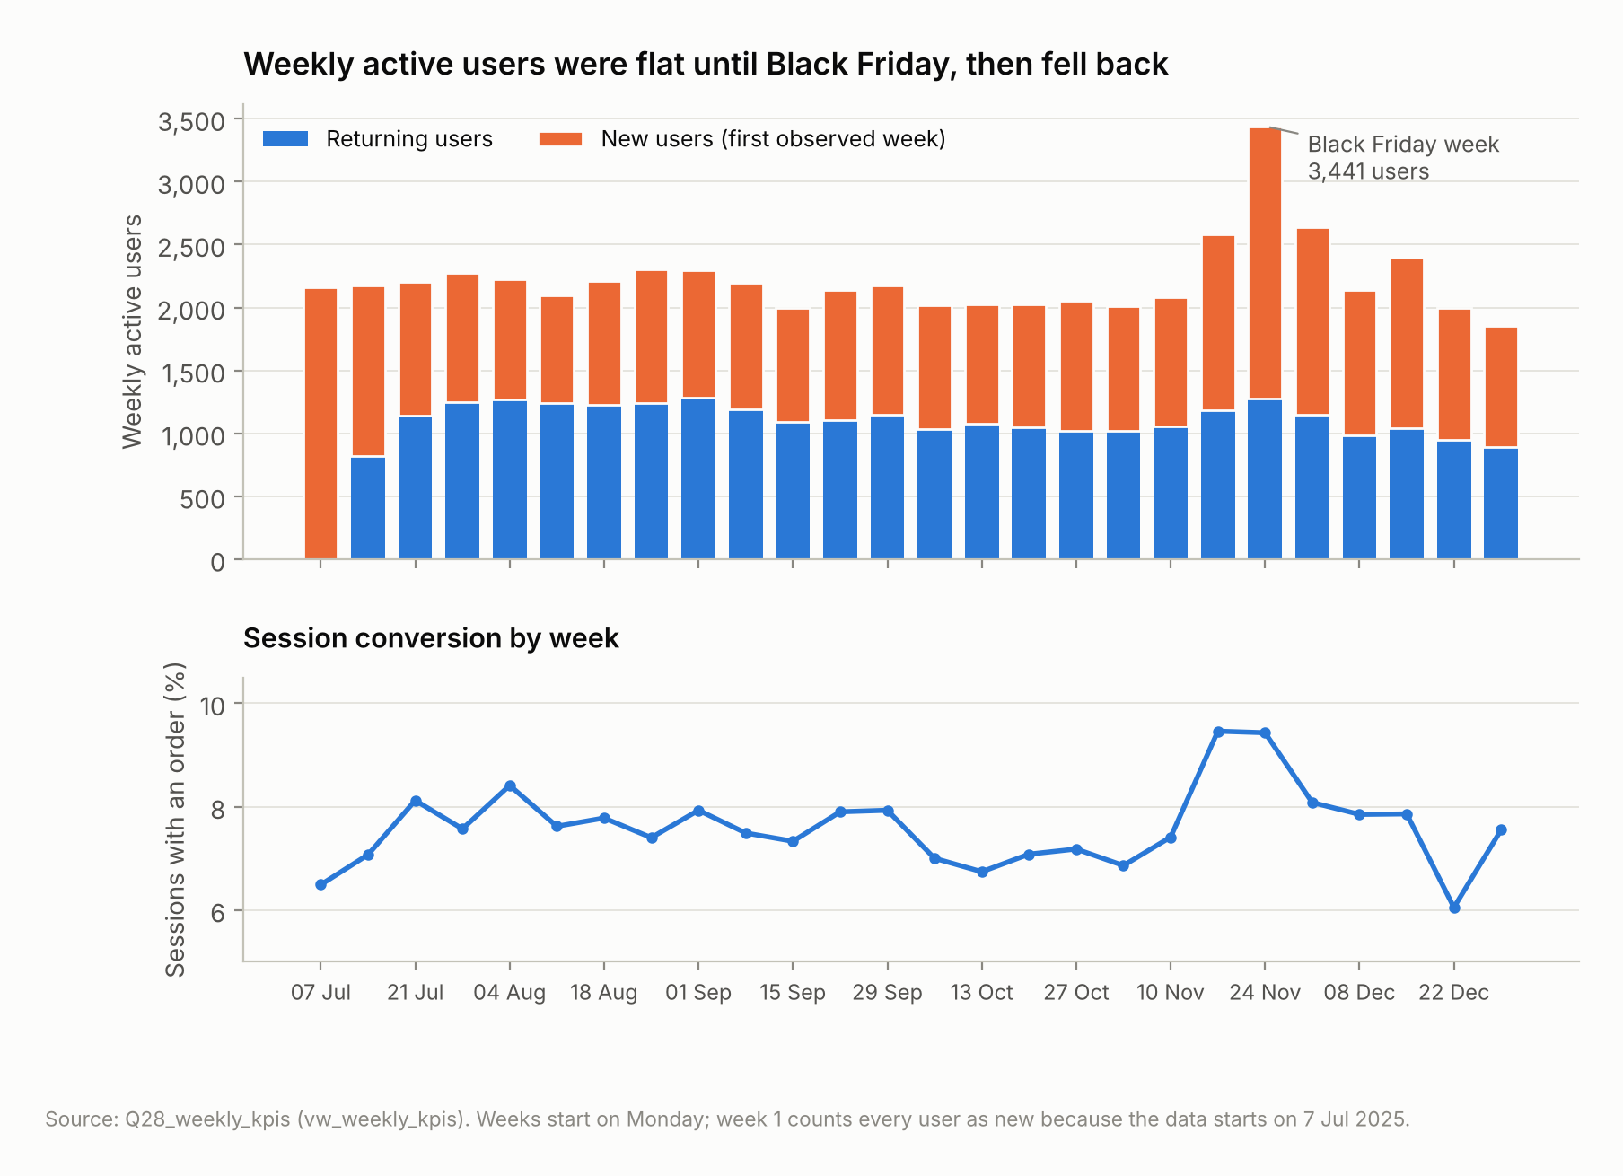
Figure 1. Weekly active users (new vs returning) and session conversion. Source: vw_weekly_kpis.
Interpretation: engagement is steady but shallow for most users. More than half visit once, a fifth of sessions contain a single event, and a typical session has three product interactions. Engagement is concentrated in a heavy minority: the 6% of users with 10+ sessions include 75.6% who ordered. Product attention is also concentrated: the top 10 products take 22.6% of views. Desktop web sessions are the most engaged and convert at 11.7%, against 5.6% for mobile web, the largest segment.
Rank | Product | Category | Views | % of views | Units rank | View→purchase
1 | Voltix Tablet K45 | Phones & Tablets | 12,399 | 3.99% | 5 | 6.29%
2 | Stride Chinos F33 | Fashion | 9,337 | 3.01% | 17 | 2.54%
3 | Voltix Soundbar T58 | Electronics | 8,000 | 2.58% | 9 | 3.51%
4 | Naturelle Vitamin C Serum D49 | Health & Beauty | 7,527 | 2.42% | 1 | 13.88%
5 | Kitchenix Air Fryer U17 | Home & Kitchen | 5,910 | 1.90% | 42 | 1.94%
6 | Lagoon Press Novel - Paperback D75 | Books & Stationery | 5,655 | 1.82% | 23 | 2.65%
7 | Corelink Laptop 14in K13 | Computing | 5,637 | 1.82% | 34 | 3.01%
8 | Farmfresh Instant Noodles (Carton) X98 | Groceries | 5,500 | 1.77% | 2 | 12.76%
9 | Stride Ankara Midi Dress G52 | Fashion | 5,230 | 1.68% | 7 | 6.03%
10 | Voltix Feature Phone V36 | Phones & Tablets | 5,130 | 1.65% | 87 | 1.43%
Top 10 most-viewed products (Q06).

7.2 Objective 2: conversion funnel
Procedure: a closed user funnel over the whole window (Q07), in which a user counts at a stage only if they also reached every earlier stage, with purchases taken from orders. A session funnel (Q08) shows behaviour within a single visit. The two are reconciled with event-tracked purchases (Q07b).
Stage | Users | Step conversion | Lost at step | % of product viewers
Visited the platform | 30,000 | - | - | -
Viewed a product | 26,810 | 89.4% | 3,190 | 100.0%
Added to cart | 11,570 | 43.2% | 15,240 | 43.2%
Began checkout | 5,884 | 50.9% | 5,686 | 21.9%
Placed an order | 4,655 | 79.1% | 1,229 | 17.4%
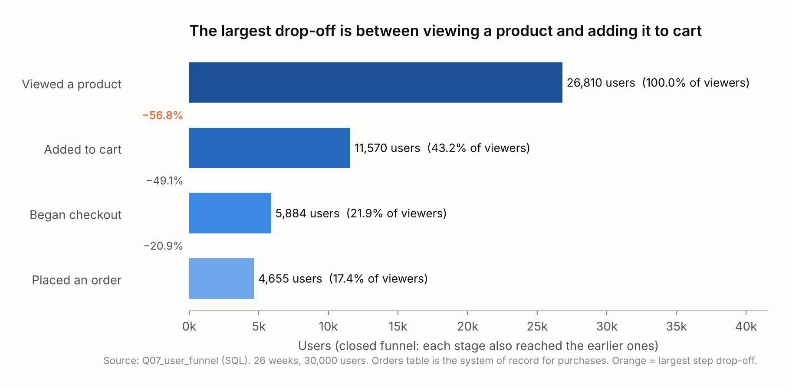
Figure 2. Closed user funnel from product view to order (Q07).
Session stage | Sessions | Step conversion | % of all sessions
All sessions | 89,557 | – | 100.0%
Viewed a product | 74,987 | 83.7% | 83.7%
Added to cart | 21,361 | 28.5% | 23.9%
Began checkout | 6,976 | 32.7% | 7.8%
Placed an order | 4,962 | 71.1% | 5.5%
Results: 26,810 users viewed a product, 11,570 added to cart (43.2% of viewers), 5,884 began checkout and 4,655 ordered (17.4% of viewers). Of cart users, 40.2% went on to order. Within a single session, only 4,962 sessions (5.5%) completed the full journey, while 6,896 sessions contained an order. That difference is the cross-session journeys.
Interpretation: the funnel loses most users at its first step. Per session the picture looks worse (only 28.5% of viewing sessions add to cart), because users spread a purchase across visits. The user funnel is the right lens for the Product Manager’s question.

7.3 Objective 3: abandonment
Procedure: the largest step drop-off is ranked in Q07. Segment funnels (Q09) locate where each step is weakest. LEAD shows the event that follows an add-to-cart (Q11). Q10 measures how long carts take to become orders. Q12 measures checkout abandonment by platform and device, and Q12b measures overall cart abandonment with a censoring-aware 7-day window.
Drop-off point | Measure | Value
View → cart | product viewers who never add to cart | 15,240 users (56.8%): largest
Cart → checkout | cart users who never begin checkout | 5,686 users (49.1%)
Checkout → order | checkout users who never order | 1,229 users (20.9%)
Checkout sessions | end without an order | 2,920 of 9,816 (29.7%)
Cart additions | not bought within 7 days | 67.9% of 28,001 with an outcome
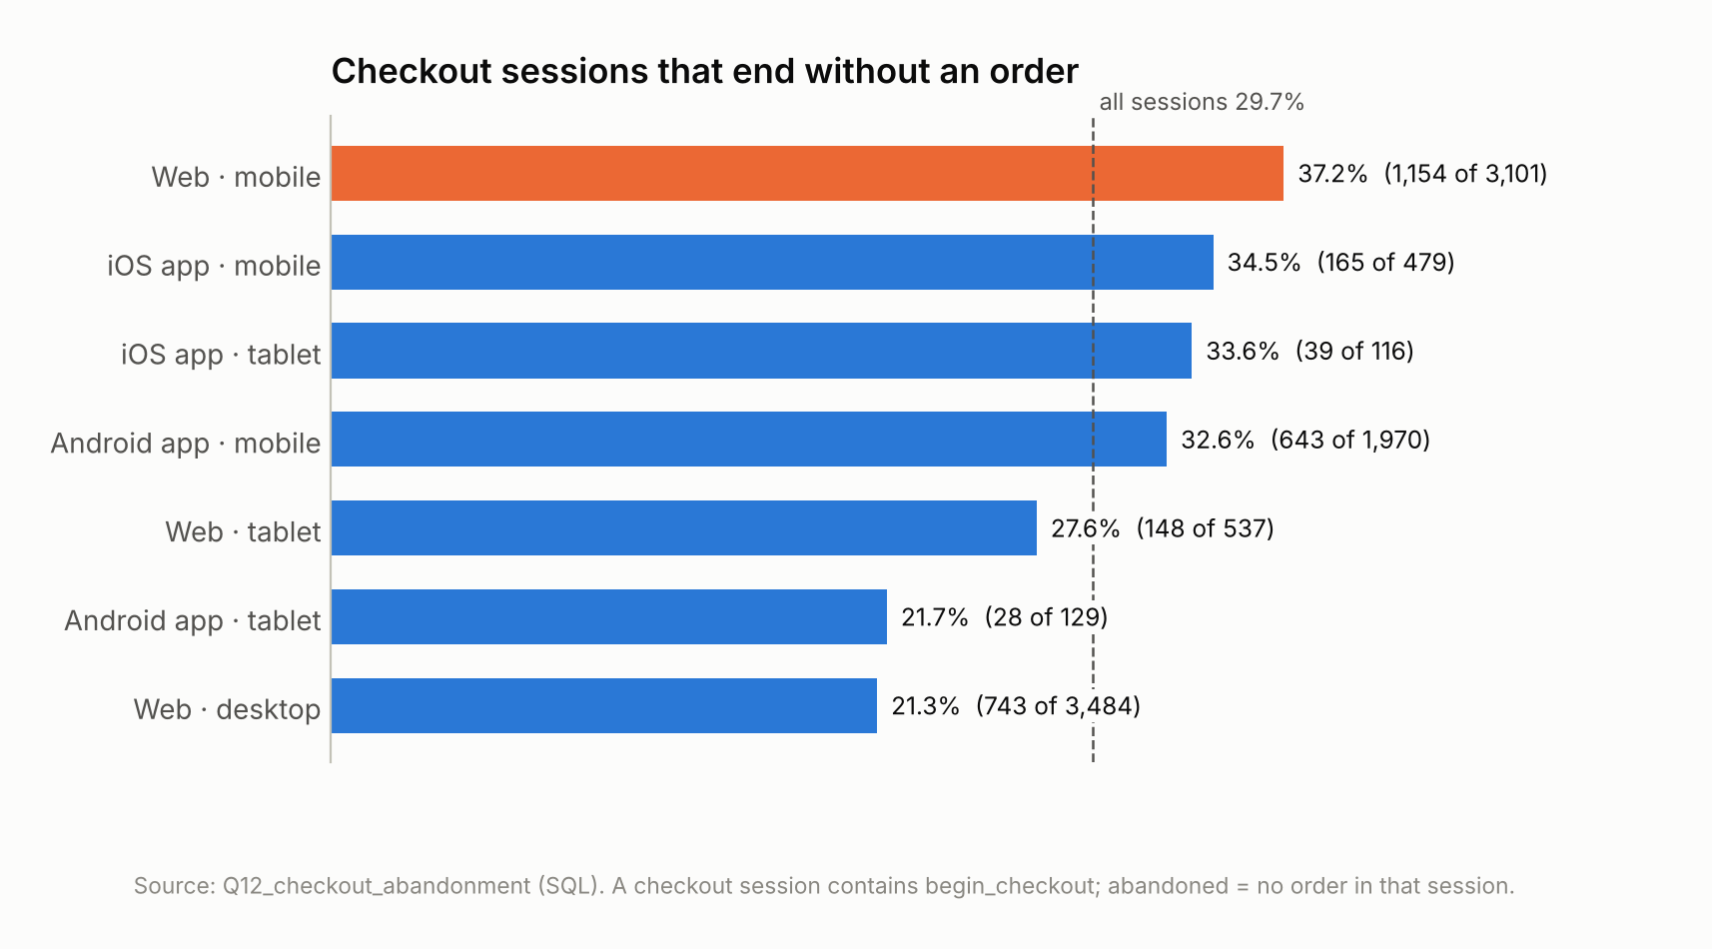
Figure 3. Checkout abandonment by platform and device (Q12).
Next event after add-to-cart |  | Events |  | %
product_view |  | 11,182 |  | 38.6%
page_view |  | 6,310 |  | 21.8%
search |  | 4,931 |  | 17.0%
(session ended) |  | 3,313 |  | 11.4%
begin_checkout |  | 1,901 |  | 6.6%
remove_from_cart |  | 1,304 |  | 4.5%
Time from last add-to-cart to order | Orders |  | % of orders |  | Cumulative
Same session | 4,960 |  | 71.9% |  | 71.9%
Earlier session, < 1 day | 379 |  | 5.5% |  | 77.4%
1-3 days | 384 |  | 5.6% |  | 83.0%
3-7 days | 518 |  | 7.5% |  | 90.5%
More than 7 days | 643 |  | 9.3% |  | 99.8%
No earlier add-to-cart | 12 |  | 0.2% |  | 100.0%
Interpretation: abandonment has three distinct shapes:
- Browsing without commitment, at the top of the funnel. Paid social is the extreme case: 18.0% view-to-cart against 34.3% for email.
- Shortlisting. After an add-to-cart, 38.6% of users view another product next and only 6.6% go to checkout. 71.9% of orders follow the last add-to-cart in the same session, and 9.3% come more than 7 days later.
- Friction at checkout, concentrated on mobile web: 37.2% abandoned against 21.3% on desktop web.

7.4 Objective 4: product and category performance
Procedure: product rankings by views and units (Q06, Q13b); Spearman rank correlations between popularity and outcomes (Q13); popularity/conversion quadrants around the catalogue medians (Q26); conversion ranking by Wilson lower bound with at least 500 viewers (Q14); high-interest, low-conversion products by NTILE quartiles against a category benchmark (Q15); category activity (Q16); and product and category cart abandonment with at least 100 observed additions (Q17, Q17b).
Rank correlation (250 products) |  |  |  | Spearman ρ
views vs net revenue |  |  |  | 0.599
views vs units sold |  |  |  | 0.517
views vs view-to-purchase rate |  |  |  | -0.177
Quadrant | Products | % of views | % of units |  | Pooled view→purchase
Traffic without sales: high traffic, low conversion | 75 | 47.4% | 20.6% |  | 2.51%
Star: high traffic, high conversion | 51 | 33.7% | 53.4% |  | 7.42%
Hidden gem: low traffic, high conversion | 75 | 11.4% | 21.8% |  | 7.04%
Low priority: low traffic, low conversion | 49 | 7.5% | 4.2% |  | 2.44%
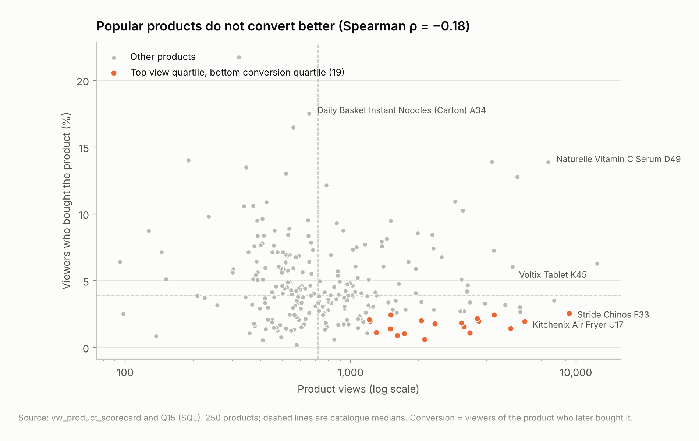
Figure 4. Product views vs view-to-purchase conversion; orange = top view quartile and bottom conversion quartile (Q15).
Do popular products necessarily generate the most purchases? No. Popular products sell more units in absolute terms (ρ = 0.52), but popularity and conversion are weakly negatively related (ρ = -0.18). Only 8 of the 20 most-viewed products are among the 20 best sellers. The “traffic without sales” quadrant takes 47.4% of views but delivers 20.6% of units.
Product (≥ 500 viewers) | Category | Viewers | Conversion | Wilson lower
Daily Basket Instant Noodles (Carton) A34 | Groceries | 553 | 17.54% | 14.60%
Naturelle Vitamin C Serum D49 | Health & Beauty | 4,229 | 13.88% | 12.87%
Glowa Shea Body Butter V48 | Health & Beauty | 2,696 | 13.91% | 12.65%
Farmfresh Instant Noodles (Carton) X98 | Groceries | 3,283 | 12.76% | 11.66%
Playmore Baby Wipes 3-Pack F67 | Baby, Kids & Toys | 643 | 12.13% | 9.83%
Ori Botanics Shea Body Butter U44 | Health & Beauty | 2,102 | 10.94% | 9.68%
Daily Basket Tea Bags 50ct V27 | Groceries | 2,136 | 10.25% | 9.04%
Mama's Pantry Parboiled Rice 5kg K20 | Groceries | 1,183 | 9.47% | 7.93%
Highest view-to-purchase conversion, ranked by the Wilson lower bound (Q14, top 8).
High views, low conversion | Views | Conversion | Category rate | Cart abandon. | Buyer gap
Stride Chinos F33 | 9,337 | 2.54% | 4.14% | 86.6% | 83
Melanin Lab Shea Body Butter X82 | 1,302 | 1.13% | 8.23% | 77.8% | 75
Voltix Feature Phone V36 | 5,130 | 1.43% | 3.35% | 61.1% | 65
Bumble Kids Sneakers P52 | 3,642 | 2.17% | 5.31% | 72.9% | 61
Kente & Co Handbag N33 | 4,331 | 2.43% | 4.14% | 69.1% | 51
Kelvo Chest Freezer 200L D32 | 3,377 | 1.11% | 2.76% | 90.3% | 39
Axiom Feature Phone Y80 | 3,701 | 1.98% | 3.35% | 71.5% | 36
Kitchenix Air Fryer U17 | 5,910 | 1.94% | 2.76% | 87.4% | 29
Q15, top 8 of 19. The category rate is the pooled product-level rate of the product’s category (a windowed SUM). Buyer gap = viewers × (category rate − product rate); the 19 products sum to 656. This sizes the gap; it is not a forecast.
Category | Orders | Buyers | Units | Conversion | % of orders | % of revenue
Health & Beauty | 1,699 | 1,409 | 3,552 | 15.5% | 18.5% | 3.6%
Groceries | 1,505 | 1,262 | 3,435 | 15.9% | 16.4% | 3.4%
Fashion | 1,414 | 1,207 | 2,131 | 9.8% | 15.4% | 6.1%
Phones & Tablets | 994 | 904 | 1,088 | 8.0% | 10.8% | 35.4%
Electronics | 828 | 750 | 1,165 | 7.7% | 9.0% | 7.4%
Baby, Kids & Toys | 773 | 694 | 1,130 | 10.3% | 8.4% | 3.9%
Home & Kitchen | 592 | 546 | 819 | 6.5% | 6.5% | 3.1%
Books & Stationery | 580 | 517 | 1,118 | 8.6% | 6.3% | 0.8%
Sports & Fitness | 408 | 378 | 557 | 7.8% | 4.5% | 2.5%
Computing | 370 | 347 | 391 | 5.2% | 4.0% | 33.8%
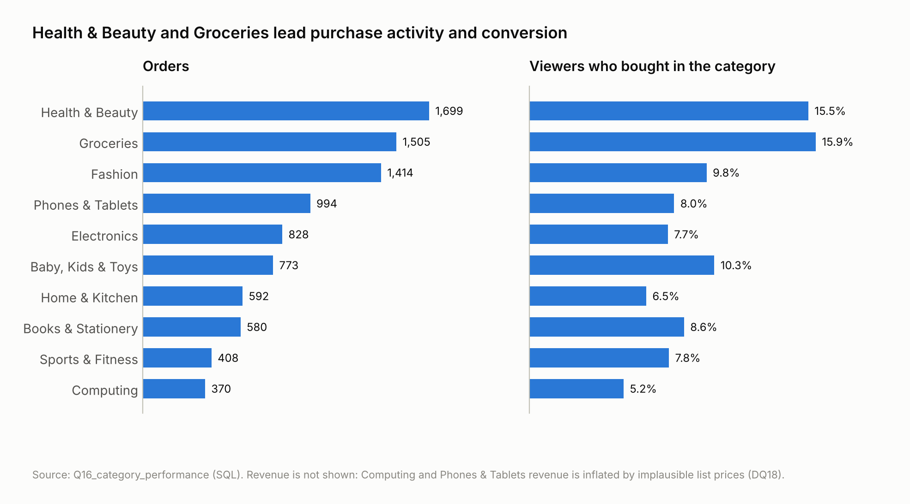
Figure 5. Orders and viewer conversion by category (Q16).
Which categories have the highest purchase activity? Health & Beauty (1,699 orders) and Groceries (1,505), which also have the highest viewer conversion (15.5% and 15.9%). Phones & Tablets and Computing lead net revenue (35.4% and 33.8%), but on few units and with implausible prices (DQ18). Revenue rankings are therefore indicative.
Highest cart abandonment (≥ 100 observed additions) | Category | Observed | Abandoned | vs category
Lekki Thread Men's Kaftan Set K73 | Fashion | 137 | 93.4% | +20.1 pp
Kente & Co Sneakers K43 | Fashion | 135 | 91.1% | +17.8 pp
Playmore Baby Stroller X62 | Baby, Kids & Toys | 108 | 90.7% | +25.1 pp
Kelvo Chest Freezer 200L D32 | Home & Kitchen | 207 | 90.3% | +15.9 pp
Kitchenix Air Fryer U17 | Home & Kitchen | 428 | 87.4% | +12.9 pp
Stride Chinos F33 | Fashion | 881 | 86.6% | +13.3 pp
Zentel Smartphone P32 | Phones & Tablets | 101 | 81.2% | +13.8 pp
Sonara Inverter 1.5kVA J13 | Electronics | 421 | 81.0% | +8.2 pp
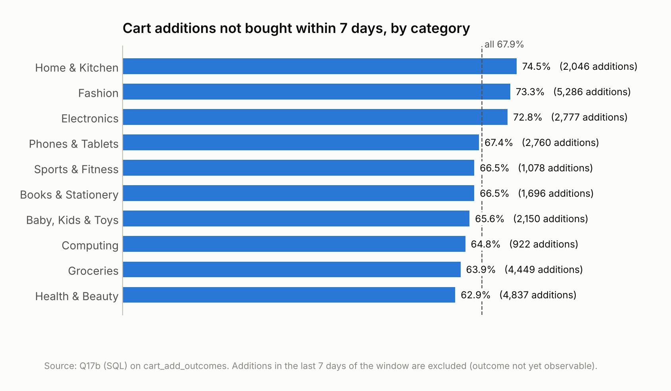
Figure 6. Cart additions not bought within 7 days, by category (Q17b).

7.5 Objective 5: returning users and retention
Procedure: return on a later day and within 7 / 14 / 28 days among eligible users (Q19); a weekly cohort retention matrix built from the recursive cohort table (Q20); pooled week-1, week-2 and week-4 retention for three populations, to handle left-censoring (Q21); the cohort quality trend (Q22); return and repeat buying by user group (Q23); and repeat purchase (Q24).
Measure | Value
Users who returned on a later day | 12,667 (42.2%), median 4 days to return
Returned within 7 / 14 / 28 days (eligible users) | 31.4% / 39.4% / 43.2%
Week 1 / 2 / 4 retention: all users | 26.5% / 19.3% / 11.0%
Week 1 / 2 / 4: cohorts 3–26 | 25.1% / 17.8% / 9.7%
Week 1 / 2 / 4: users not registered before the window | 20.0% / 13.8% / 6.8%
Repeat buyers; share of orders; median days between orders | 28.4% of buyers; 51.7%; 10.1 days
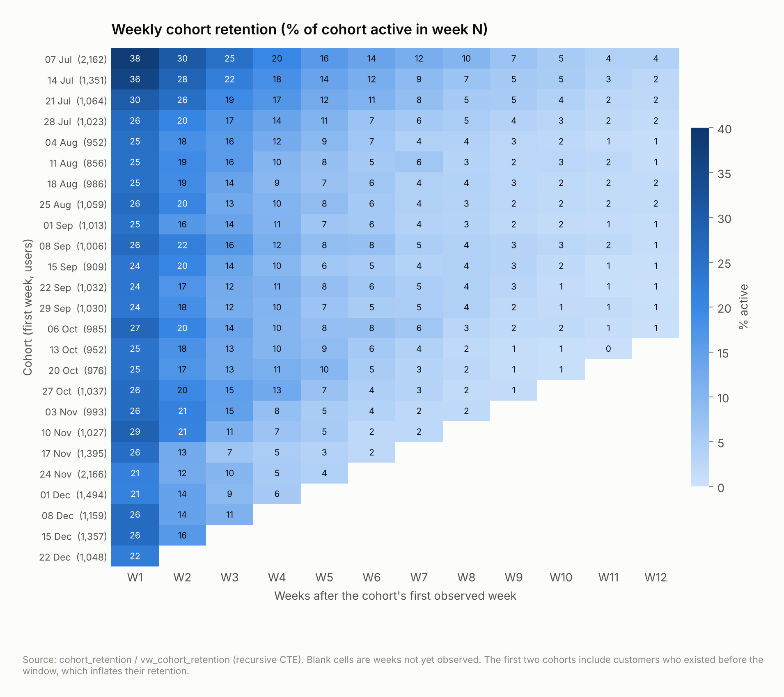
Figure 7. Weekly cohort retention, weeks 1–12 (cohort_retention).
Group | Users eligible (28 d) | Return within 28 days | vs overall | Repeat buyers
Channel: email | 1,222 | 71.7% | +28.5 pp | 39.2%
Channel: direct | 3,452 | 61.8% | +18.6 pp | 34.2%
Channel: organic_search | 6,748 | 46.6% | +3.4 pp | 27.1%
Channel: paid_search | 3,455 | 40.3% | -2.9 pp | 22.8%
Channel: affiliate | 2,225 | 34.8% | -8.4 pp | 26.4%
Channel: paid_social | 5,419 | 25.0% | -18.2 pp | 21.5%
loyalty member: member | 1,833 | 88.5% | +45.3 pp | 45.2%
loyalty member: not a member | 23,635 | 39.7% | -3.5 pp | 23.5%
registration: registered | 9,388 | 74.2% | +31.0 pp | 28.4%
registration: guest | 16,080 | 25.1% | -18.1 pp | -
primary device: desktop | 6,265 | 45.5% | +2.3 pp | 33.6%
primary device: mobile | 17,413 | 42.5% | -0.7 pp | 25.4%
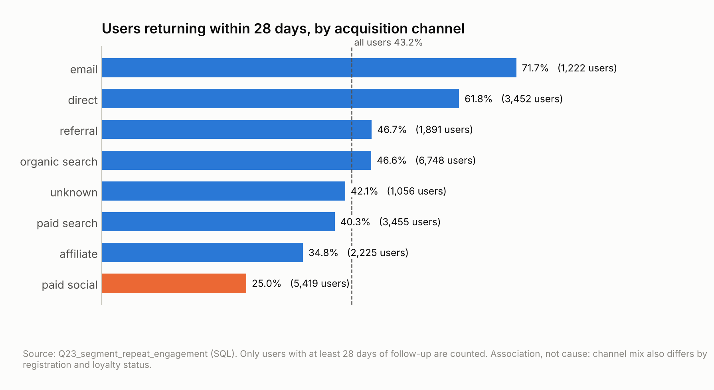
Figure 8. 28-day return by acquisition channel (Q23).
Interpretation: retention is decided early. The median user who returns does so within 4 days, and retention roughly halves between week 1 and week 4. Week-1 retention was stable at about 24-29% for the cohorts from late July to mid-November. The Black Friday cohorts (1,395 and 2,166 users) had lower week-4 retention (4.9%, 5.3%). This fits deal-driven acquisition, but those cohorts reach week 4 during the late-December slowdown, so the two cannot be separated. Email-acquired, registered and loyalty users return far more. Registration and loyalty are recorded at extract date, however, so the direction of these associations is unknown.

7.6 Objective 6: opportunities
Procedure: Q25 consolidates the size of each leak. Promotion periods are compared per day (Q18). Two gaps are sized by applying a benchmark rate to a segment (shown below). These sizes indicate scale and are not forecasts.
Priority | Opportunity | Size | Base
1 | Viewers who never add to cart | 15,240 | 56.8% of product viewers
2 | Cart users who never reach checkout | 5,686 | 49.1% of cart users
3 | Checkout sessions that end without an order | 2,920 | 29.7% of checkout sessions
4 | Cart additions not bought within 7 days | 19,020 | 67.9% of cart additions with an outcome
5 | High-traffic, low-converting products | 19 | 7.6% of the catalogue (top view quartile, bottom conversion quartile)
6 | Users seen in only one session | 16,704 | 55.7% of all users
Mobile-web checkout gap: 3,101 checkout sessions × (37.21% - 21.33%) ≈ 493 orders over 26 weeks, 7.1% of all orders, if mobile web completed checkouts at the desktop-web rate.
High-traffic, low-conversion products: the 19 products in Q15 would add about 656 product purchases (buyer-product pairs) if they converted at their category rate.
Period | Days | Sessions per day | View→cart | Session conversion | Avg net order value
No promotion | 122 | 450 | 28.1% | 7.44% | 82,554
Back-to-School Sale | 21 | 506 | 28.0% | 7.61% | 95,488
Independence Day Deals | 7 | 476 | 28.8% | 7.93% | 88,618
Black Friday | 10 | 864 | 32.0% | 9.36% | 78,570
Cyber Week Tech Deals | 5 | 678 | 27.4% | 7.73% | 83,034
Festive Season Sale | 13 | 531 | 29.1% | 7.59% | 68,357
New Year Clearance | 4 | 437 | 26.7% | 8.13% | 55,247

7.7 Objective completion
Objective | Status | Main evidence
1 Engagement | Complete | Q01–Q06b, Q27, Q28; Figure 1
2 Conversion funnel | Complete | Q07, Q07b, Q08; Figure 2
3 Abandonment stages | Complete | Q07 (ranked drop-offs), Q09–Q12b; Figure 3
4 Product and category performance | Complete. Revenue ranking is indicative only (DQ18) | Q13–Q17b, Q26; Figures 4–6
5 Returning users and retention | Complete, with censoring corrections | Q19–Q24; Figures 7–8
6 Opportunities | Complete. Sizes are not forecasts | Q25, Q18, Sections 8–9

8. Key findings
- The top of the funnel is the biggest leak. 56.8% of product viewers (15,240 users) never add to cart. Cart → checkout loses 49.1%, and checkout → order loses 20.9%.
- Mobile-web checkout loses intent. 37.2% of mobile-web checkout sessions end without an order, against 21.3% on desktop web. Mobile web is the largest segment and converts at 5.6%.
- The cart is a shortlist and journeys span sessions. 38.6% of add-to-carts are followed by another product view. 67.9% of additions are not bought within 7 days, and 28% of orders complete a journey from an earlier session.
- Popularity does not mean conversion. The rank correlation of views with conversion is -0.18. 75 products take 47.4% of views but 20.6% of units, while 75 “hidden gems” convert at 7.04% on 11.4% of views.
- Consumables drive purchase activity. Health & Beauty and Groceries lead orders and conversion, and have the lowest cart abandonment.
- Retention is decided in the first week. Week-1 retention is 26.5% and week-4 is 11.0%. The median return comes after 4 days.
- Channel quality differs. 28-day return is 71.7% for email-acquired users and 25.0% for paid social. Paid-social sessions convert at 3.5%.
- Black Friday doubled daily sessions (864 vs 450) and raised conversion (9.4% vs 7.4%), but its cohorts retained worse. That comparison is confounded with the December slowdown.
- Repeat buyers matter. 28.4% of buyers placed 51.7% of orders.
- The data itself needs fixing. The event stream misses 2.99% of orders, and 12 products carry implausible prices.

9. Business recommendations
Each recommendation follows from a finding above. Associations are treated as hypotheses to test, not as proven effects.
Horizon | Recommendation | Evidence | Success measure
Immediate (0-4 weeks) | Fix purchase-event tracking; schedule the events-vs-orders reconciliation (V11, V26) | DQ08, Q07b | 0 orders missing from events
Immediate | Audit the 12 implausible catalogue prices | DQ18, Q16 | DQ18 = 0
Immediate | Audit the mobile-web checkout (form length, payment options, speed, errors) and fix obvious friction | Q12, Q09 | Mobile-web checkout abandonment
Immediate | Review the 19 high-traffic, low-conversion product pages (price, images, size/spec, reviews, stock) | Q15, Q26 | Product view-to-purchase
Medium (1–3 months) | A/B test the mobile-web checkout redesign | Q12 | Checkout → order on mobile web
Medium | A/B test a persistent cross-device cart, save-for-later, and a cart reminder 24–72 h after an addition | Q10, Q11, Q12b | 7-day cart conversion
Medium | First-week re-engagement for new users, triggered by inactivity | Q19, Q21 | Week-1 and week-4 retention of new cohorts
Medium | Judge paid social on downstream add-to-cart, orders and 28-day return; review targeting | Q09, Q23 | Orders and returns per paid-social user
Medium | Give more placement to hidden-gem products; test replenishment reminders on consumables | Q26, Q14, Q16 | Units per view; repeat-buyer rate
Long term (3-12 months) | Randomised tests of registration and loyalty prompts before scaling them | Q23 | Incremental retention vs control
Long term | Track promotion cohorts after each event; a cohort dashboard on vw_cohort_retention and vw_weekly_kpis | Q22, Q18 | Adopted by the PM team
Long term | Cross-device identity, event data contracts, and marketing cost data for channel return | DQ11, Q23 | Stitched journeys; cost per retained buyer

10. Technical and analytical limitations

10.1 Observed data limitations
- The data is synthetic: the patterns demonstrate the method only.
- Tracking loss affects 3% of orders, so purchases are counted from orders.
- 1,414 product views and 127 cart additions are untraceable to a product.
- 12 products have implausible prices, which makes revenue rankings indicative.
- Registration, loyalty and channel are recorded at extract date.
- The currency is not stated, and there is no cost, margin or spend data.

10.2 Methodological limitations
- The analysis is observational: segment differences are associations. Registration and loyalty effects may be reverse causation.
- Left-censoring inflates cohorts 1-2, so retention is also reported excluding them. Right-censoring is handled with NULL flags and observed-only cohort cells.
- The 7-day abandonment window counts the 9.3% of orders that come later than 7 days as abandoned.
- Viewer-buyer attribution means a viewer ordered the same product at any time in the window. It does not show that the view caused the order.
- Black Friday cohort retention is confounded with December seasonality.
- Minimum samples (500 viewers, 100 cart additions) leave smaller products unranked.
- Opportunity sizes are scale indicators, not forecasts.

10.3 Contextual limitations
- 26 weeks cannot show year-over-year seasonality.
- There are no page-level, search-term, error or checkout-step events, so the analysis shows where users drop off but not why.
- Users who switch devices without logging in appear as separate IDs.

10.4 Assumptions
- Orders are the authoritative record of purchases. A net order is not cancelled or returned; revenue = items_subtotal, excluding shipping.
- A returning user is active on a later calendar day. Weeks run Monday to Sunday (calendar table). Prices are in NGN.
- A NULL signup_date means a guest. A signup before 7 Jul 2025 means a known existing customer. No bot traffic is present.

10.5 Information that would strengthen the analysis
The most useful additions would be page-level and checkout-step events, A/B test assignments, marketing spend by channel, product cost and margin, a reference price list, and a longer history.

11. Validation and quality assurance

11.1 Reconciliation and business-rule checks
ID | Category | Check | Expected | Actual | Status
V01 | record counts | source tables loaded with no row loss (tables failing) | 0 | 0 | PASS
V02 | record counts | events_enriched rows = events rows | 590,648 | 590,648 | PASS
V03 | record counts | every event mapped to a calendar week (unmapped events) | 0 | 0 | PASS
V04 | record counts | session_summary rows = sessions rows | 89,557 | 89,557 | PASS
V05 | record counts | user_summary rows = users rows | 30,000 | 30,000 | PASS
V06 | duplicates | duplicate event_id in events_enriched | 0 | 0 | PASS
V07 | duplicates | duplicate cart additions in cart_add_outcomes | 0 | 0 | PASS
V08 | join integrity | foreign-key violations (PRAGMA foreign_key_check) | 0 | 0 | PASS
V09 | aggregation | sum of session event counts = events | 590,648 | 590,648 | PASS
V10 | aggregation | sum of user session counts = sessions | 89,557 | 89,557 | PASS
V11 | aggregation | orders in session_summary = orders | 6,896 | 6,896 | PASS
V12 | aggregation | product views in product_performance = traceable product_view events | 310,541 | 310,541 | PASS
V13 | aggregation | units in product_performance = units in order_items | 15,386 | 15,386 | PASS
V14 | aggregation | weekly cohort sizes sum to all users | 30,000 | 30,000 | PASS
V15 | reconciliation | net revenue: user_summary = orders table | 512,197,600 | 512,197,600 | PASS
V16 | reconciliation | net revenue: product_performance = order_items of net orders | 512,197,600 | 512,197,600 | PASS
V17 | reconciliation | net revenue: category_performance = product_performance | 512,197,600 | 512,197,600 | PASS
V18 | reconciliation | closed user funnel final stage = all buyers (every buyer passed every stage) | 4,655 | 4,655 | PASS
V19 | reconciliation | weekly orders in vw_weekly_kpis = orders | 6,896 | 6,896 | PASS
V20 | reconciliation | daily net revenue in vw_daily_kpis = user_summary net revenue | 512,197,600 | 512,197,600 | PASS
V21 | business rule | user funnel never increases from one stage to the next (violations) | 0 | 0 | PASS
V22 | business rule | week-0 retention is 100% for every cohort (violations) | 0 | 0 | PASS
V23 | business rule | retention and conversion rates within [0, 1] (violations) | 0 | 0 | PASS
V24 | business rule | every order session contains a begin_checkout event (orders without) | 0 | 0 | PASS
V25 | business rule | a same-session purchase is also a purchase within 7 days (violations) | 0 | 0 | PASS
V26 | business rule | event-tracked buyers do not exceed order-based buyers (excess) | 0 | 0 | PASS
V27 | business rule | censored return flags only for users with too little follow-up (violations) | 0 | 0 | PASS

11.2 Further QA performed
QA step | How it was tested | Result
Script runs end to end in the sqlite3 shell | sqlite3 -bail with the full file on a fresh database | Exit code 0, 33.4 s
Script runs through the runner | run_sql_project.py --fresh | 70 blocks, 35.5 s, no errors
Two execution paths agree | MD5 of the full contents of every table and view in both databases | 30 objects compared, 0 differ
Checks can detect errors | On a copy: deleted one ordered session and added 1 unit to one product, then re-ran Section 7 | V04, V09, V11, V13, V19 and V20 failed, as expected
Raw data unchanged | MD5 of the raw file before and after | 451c337ac01d6286b2a1575b246ed178 = 451c337ac01d6286b2a1575b246ed178
Load completeness | Source vs loaded row counts | 10/10 PASS
Constraint integrity | PK / FK / UNIQUE / CHECK at load; PRAGMA foreign_key_check | No rejections; 0 violations
Numbers in documents | The report is generated from the exported CSVs; README and docs figures cross-checked against the same files | No hand-typed results in this report
Charts | Each chart rendered and inspected for overlap, labels and correctness | 9 charts from actual outputs

11.3 Issues that remain unresolved
- The implausible prices (DQ18) cannot be corrected without a reference price list, so revenue rankings remain indicative.
- Seasonality and acquisition quality cannot be separated for the Black Friday cohorts.
- The causal effect of registration, loyalty and channel is unknown without experiments.

12. Lessons and professional competencies demonstrated
Competency | Where it shows
Business problem-solving | Translated the Product Manager’s questions into precise metric definitions and an objective-to-query map. Ended with prioritised, sized opportunities
Data preparation | Constrained schema, staging with type conversion, a 19-check DQ register, keep-and-flag cleaning, derived analysis layer
Tool proficiency (SQL) | Multi-CTE pipelines, recursive CTE, ROW_NUMBER, RANK, DENSE_RANK, NTILE, LAG, LEAD, running totals, moving averages, custom frames, FILTER, EXISTS, views, PRAGMAs, ATTACH
Analytical thinking | Chose orders over events, and the user funnel over the session funnel, on evidence. Separated three kinds of abandonment
Statistical reasoning | Medians, Spearman correlation and Wilson bounds in SQL. Censoring corrections. Minimum samples. Caution about confounding and reverse causation
Data modelling | Grain-aware derived tables (event, session, user, user-week, cohort, cart addition, product, category) with keys and indexes
Performance engineering | Diagnosed planner problems; rewrote queries as anti-joins and indexed EXISTS (116 s → 0.2 s)
Quality assurance | 27 automated checks, a seeded-error test, two-path equivalence, raw-file checksum
Reporting and communication | Finding comments in the SQL, charts, this report, README, recommendations by horizon

Lessons
- Reconcile the event stream with the transactional system first. It decided how every purchase metric was defined.
- In SQLite, qualify DROP statements when another database is attached, and attach sources read-only.
- Censoring is easy to miss in retention. NULL-able outcome flags make it explicit and keep denominators honest.
- Read the query plan before adding hardware: the slowest steps were planner choices, not data volume.

13. Conclusion
The project turned 590,648 raw events into a validated SQL analytics layer and answered every question in the brief.
- Engagement is steady but shallow: 55.7% of users visit once.
- Abandonment is greatest at the first funnel step: 56.8% of viewers never add to cart.
- Checkout is weakest on mobile web: 37.2% abandoned, against 21.3% on desktop.
- Popular products do not convert better, and consumables lead purchase activity.
- Retention is decided in the first week: 26.5% at week 1 and 11.0% at week 4.
For the Product Manager this gives a clear order of work: fix tracking and catalogue data, remove mobile-web checkout friction, repair or re-merchandise high-traffic products that do not convert, make carts persistent, and win users back in their first week. Each change should be tested, because the data shows associations, not causes. The SQL file runs end to end in about 36 seconds, and its 27 validation checks all pass, so the analysis can be refreshed and trusted as new data arrives.

Appendix A. Result files
File (outputs/results/) | Question or content | Rows
Q00_load_audit.csv | Source rows vs loaded rows for every table (load audit) | 10
Q00_dq_register.csv | The data-quality register, DQ01–DQ19, with affected rows and actions | 19
Q00_column_completeness.csv | Column-level NULL profile of the event table (completeness by event type). | 7
Q00_outlier_profile.csv | Distribution of sessions per user and events per session: percentiles from ROW_NUMBER (SQLite has no PERCENTILE_CONT). | 2
Q00_derived_table_sizes.csv | Row counts of the derived tables built in Section 4 | 9
Q01_platform_overview.csv | How many unique users interacted with the platform, and how many product views were recorded? | 1
Q02_session_engagement.csv | What is the average number of product interactions per session? | 1
Q03_return_frequency.csv | How frequently do users return? Distribution of users by number of sessions, with running cumulative share. | 6
Q03b_time_between_sessions.csv | When users come back, how soon? Gaps between consecutive sessions (LAG, already stored as days_since_prev_session). | 1
Q04_weekly_engagement_trend.csv | How does engagement move week by week? WAU, new vs returning users, week-over-week change (LAG), 4-week moving average (window AVG) and the | 26
Q05_engagement_by_platform.csv | Does engagement differ by platform and device? Share of sessions, interactions and conversion per segment, compared with the overall rate (w | 7
Q06_top_viewed_products.csv | Which products receive the most views? Top 15 with share of all traceable views and running cumulative share. | 15
Q06b_view_concentration.csv | How concentrated is attention? Share of views captured by the top 10, 25 and 50 products (Pareto check). | 3
Q07_user_funnel.csv | How many users viewed products, added to cart, began checkout and purchased? Where is the largest drop? Closed funnel: each stage counts use | 5
Q07b_purchase_reconciliation.csv | Reconciles the order-based purchase stage with the event stream (tracking-loss check from DQ08). | 1
Q08_session_funnel.csv | Session-level funnel (all stages within the same session). Shows how much of the drop-off is "not yet": 28% of orders happen in a session wi | 5
Q09_funnel_by_segment.csv | Where does the drop-off differ? Session step rates by platform/device and by traffic source, with the difference from the overall rate in pe | 14
Q10_cart_to_order_timing.csv | How long do purchase journeys take? For each order, the time since the user's most recent add-to-cart. | 6
Q11_after_add_to_cart.csv | What do users do immediately after adding to cart? Next event in the same session (LEAD). | 6
Q12_checkout_abandonment.csv | Of sessions that reach checkout, how many end without an order, and does it differ by platform and device? | 8
Q12b_cart_abandonment_overall.csv | Cart abandonment at the level of individual cart additions (traceable products, 7-day outcome window). | 1
Q13_popularity_vs_purchases.csv | Do popular products necessarily generate the most purchases? Spearman rank correlation between views and units sold (and between views and c | 3
Q13b_top_viewed_vs_top_sellers.csv | The overlap between the 20 most viewed and the 20 best-selling products (by units). | 1
Q14_top_conversion_products.csv | Which products have the highest view-to-purchase conversion? Products with at least 500 viewers, ranked by the 95% Wilson lower bound so tha | 15
Q15_high_interest_low_conversion.csv | Opportunity list: products in the top quartile for views but the bottom quartile for conversion (NTILE). Benchmark = the pooled product-leve | 19
Q16_category_performance.csv | Which categories have the highest purchase activity? Orders, buyers, units and net revenue with ranks. | 10
Q17_cart_abandonment_products.csv | Which products experience relatively high cart abandonment? Products with at least 100 cart additions that have a 7-day outcome, compared wi | 15
Q17b_abandonment_by_category_and_price.csv | Is abandonment linked to price? Cart abandonment by category and by list-price band (NTILE price quintiles). | 15
Q18_promotion_periods.csv | How do sessions behave during promotion periods? Descriptive comparison of promotion days with other days (not a causal estimate: promotion | 7
Q19_returning_users.csv | How many users returned after their first observed interaction? Return within 7/14/28 days uses only users with enough follow-up (right-cens | 1
Q20_cohort_retention_matrix.csv | How does activity change across weekly cohorts? Share of each first-seen weekly cohort active in each later week (pivot by conditional aggre | 26
Q21_retention_week_1_2_4.csv | What proportion of users return after one, two or four weeks? Week-N retention = active in calendar week (cohort week + N), pooled over ever | 9
Q22_cohort_quality_trend.csv | Are later cohorts as engaged as earlier ones? Per cohort: size, week-1 and week-4 retention, orders per user in the first 4 weeks, and the c | 26
Q23_segment_repeat_engagement.csv | Which user groups show stronger repeat engagement? For each grouping: users, 28-day return rate (users with 28 days of follow-up), average a | 31
Q24_repeat_purchase.csv | Repeat buying: buyers with 2+ orders and the time between consecutive orders (LAG over each buyer's orders). | 1
Q25_opportunity_summary.csv | Consolidated opportunity sizes from the funnel, abandonment, product and retention outputs | 6
Q26_product_quadrants.csv | Do popular products necessarily generate the most purchases? Products and views by quadrant. | 4
Q27_daily_kpis.csv | Daily KPIs from vw_daily_kpis (7-day moving averages, running totals, same day last week) | 182
Q28_weekly_kpis.csv | Weekly KPIs from vw_weekly_kpis (new vs returning, week-over-week change, 4-week moving average) | 26
Q99_validation_results.csv | All 27 validation checks with expected value, actual value and status | 27
Q99_validation_summary.csv | Number of validation checks passed and failed | 1

Appendix B. Repository structure
ecommerce-product-analytics-sql/
├── data/
│ ├── processed/
│ │ ├── cart_add_outcomes.csv
│ │ ├── category_scorecard.csv
│ │ ├── cohort_retention.csv
│ │ ├── ecommerce_analytics.db (build artifact, git-ignored)
│ │ ├── events_enriched.csv.gz
│ │ ├── product_scorecard.csv
│ │ ├── session_funnel_by_segment.csv
│ │ ├── session_summary.csv
│ │ └── user_summary.csv
│ ├── raw/
│ │ └── ecommerce_clean.sqlite
│ └── data_dictionary.md
├── docs/
│ ├── data_quality_and_cleaning_log.md
│ ├── insights_and_recommendations.md
│ ├── kpi_definitions.md
│ ├── limitations.md
│ ├── portfolio_positioning.md
│ ├── project_brief.md
│ └── qa_checklist.md
├── outputs/
│ ├── figures/
│ │ ├── 01_user_funnel.png
│ │ ├── 02_weekly_active_users.png
│ │ ├── 03_cohort_retention_heatmap.png
│ │ ├── 04_product_views_vs_conversion.png
│ │ ├── 05_category_performance.png
│ │ ├── 06_checkout_abandonment_by_device.png
│ │ ├── 07_retention_by_acquisition_channel.png
│ │ ├── 08_cart_abandonment_by_category.png
│ │ └── 09_sql_shell_output.png
│ └── results/ (41 query outputs + _run_log.csv)
├── reports/
│ ├── Ecommerce_Product_Analytics_Analyst_Report.docx
│ └── Ecommerce_Product_Analytics_Analyst_Report.pdf
├── scripts/
│ ├── make_charts.py
│ └── run_sql_project.py
├── sql/
│ └── ecommerce_product_analytics.sql
├── .gitignore
├── README.md
└── requirements.txt

